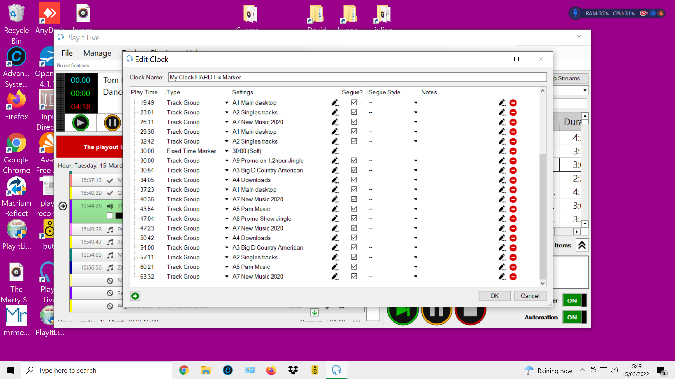
Clock’s Track Group A9 promo on ½ hour
Loading tracks.
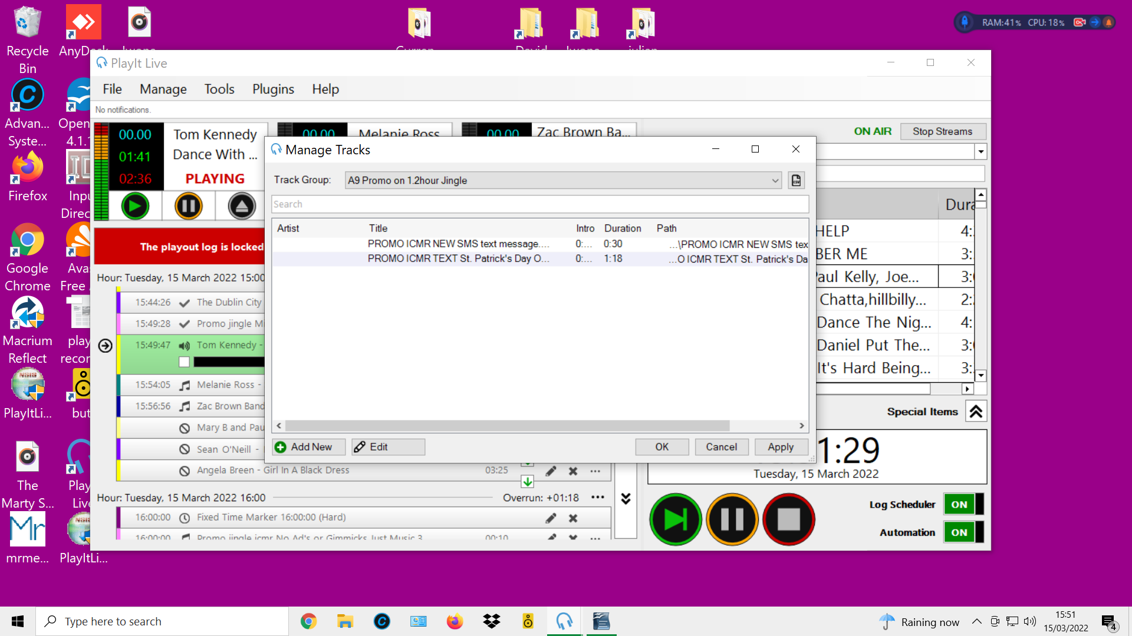
Manage>I click manage tracks> tracks > Select the Track Group folder I want Tracks to go into,
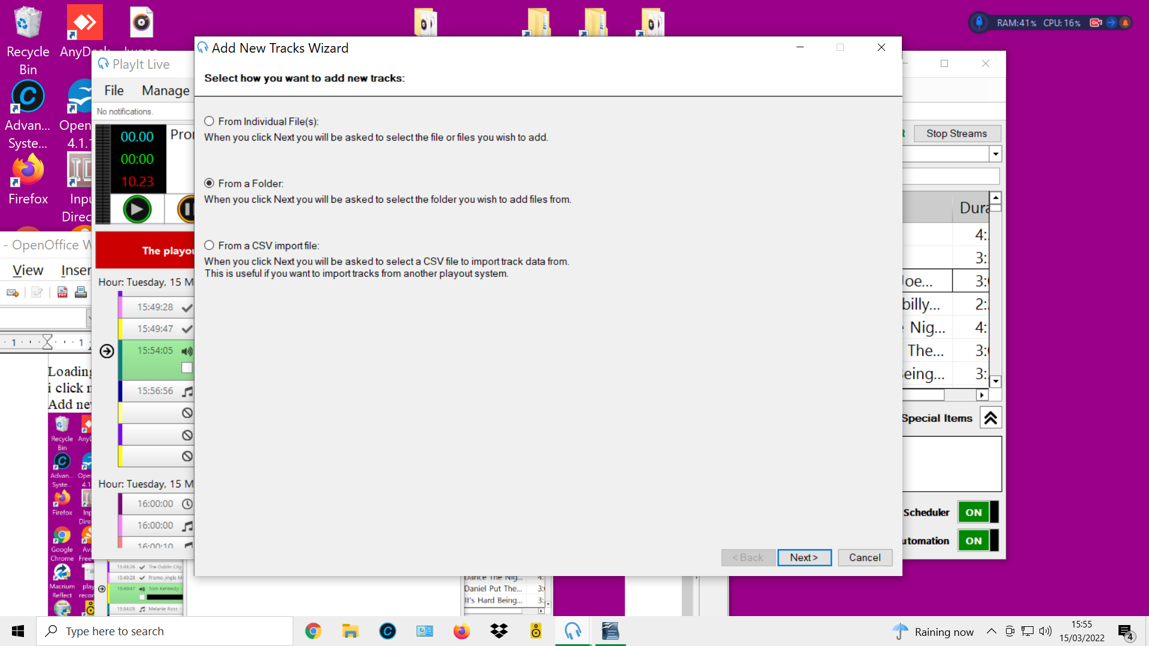
Add new>

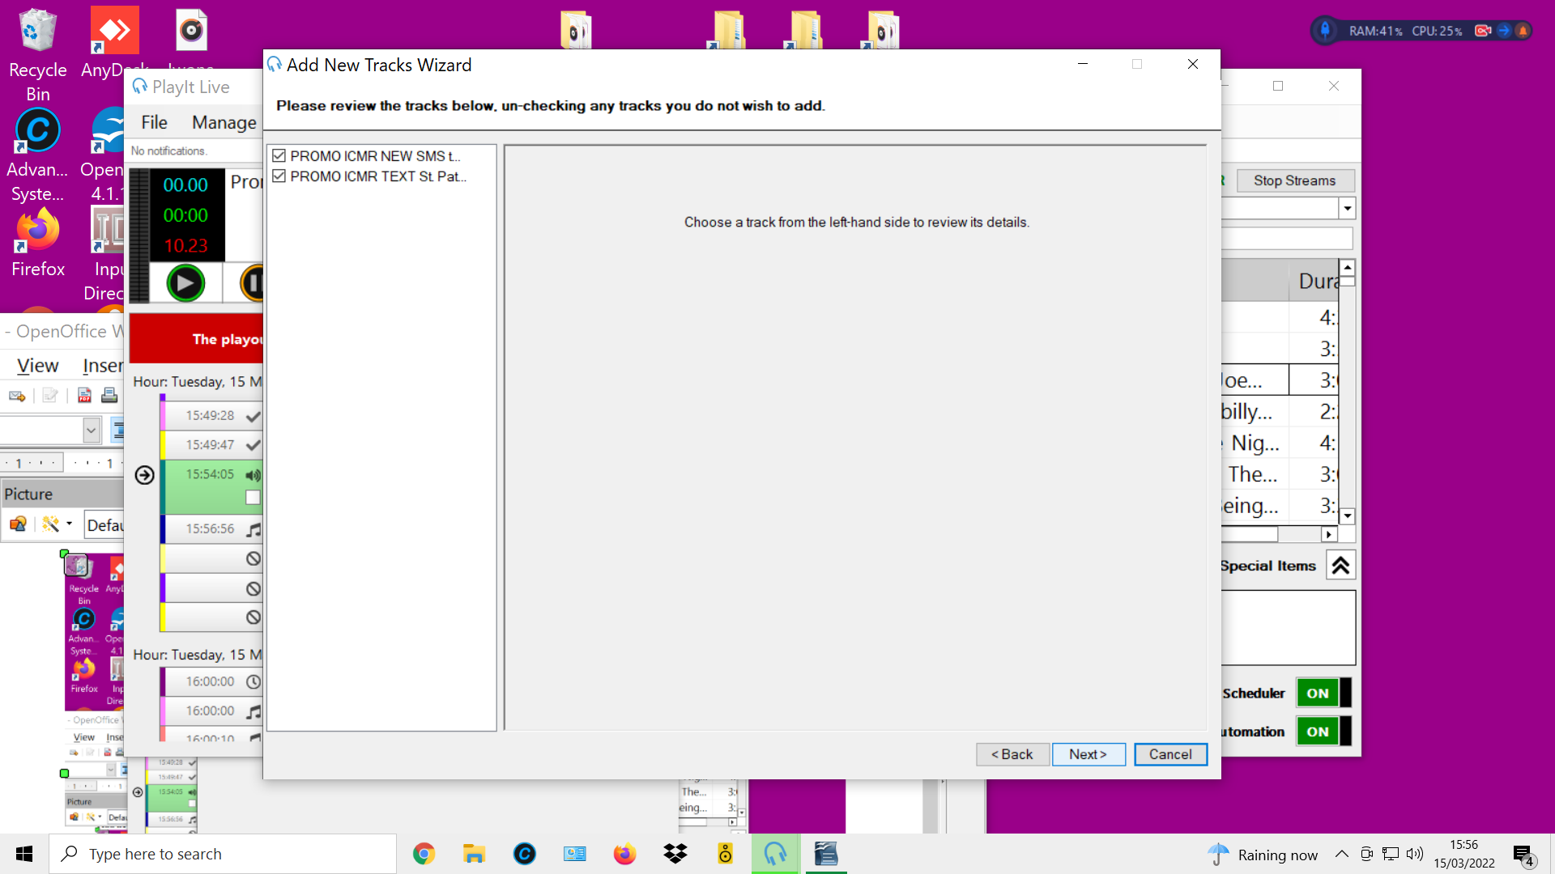
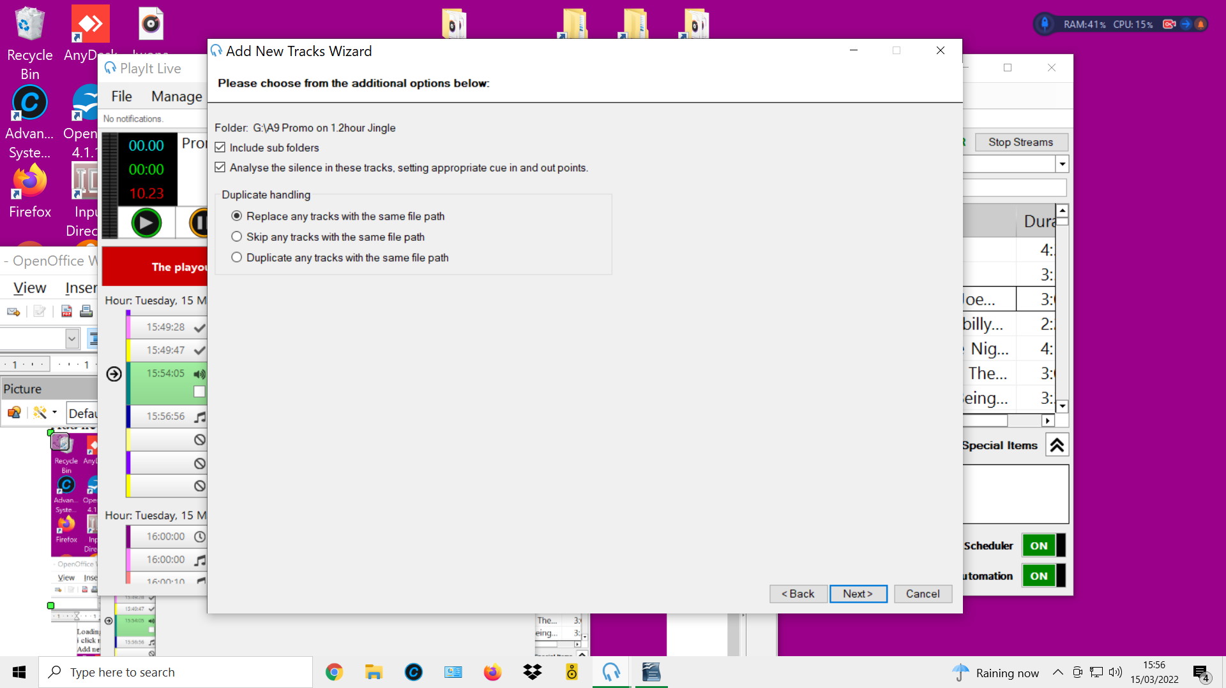

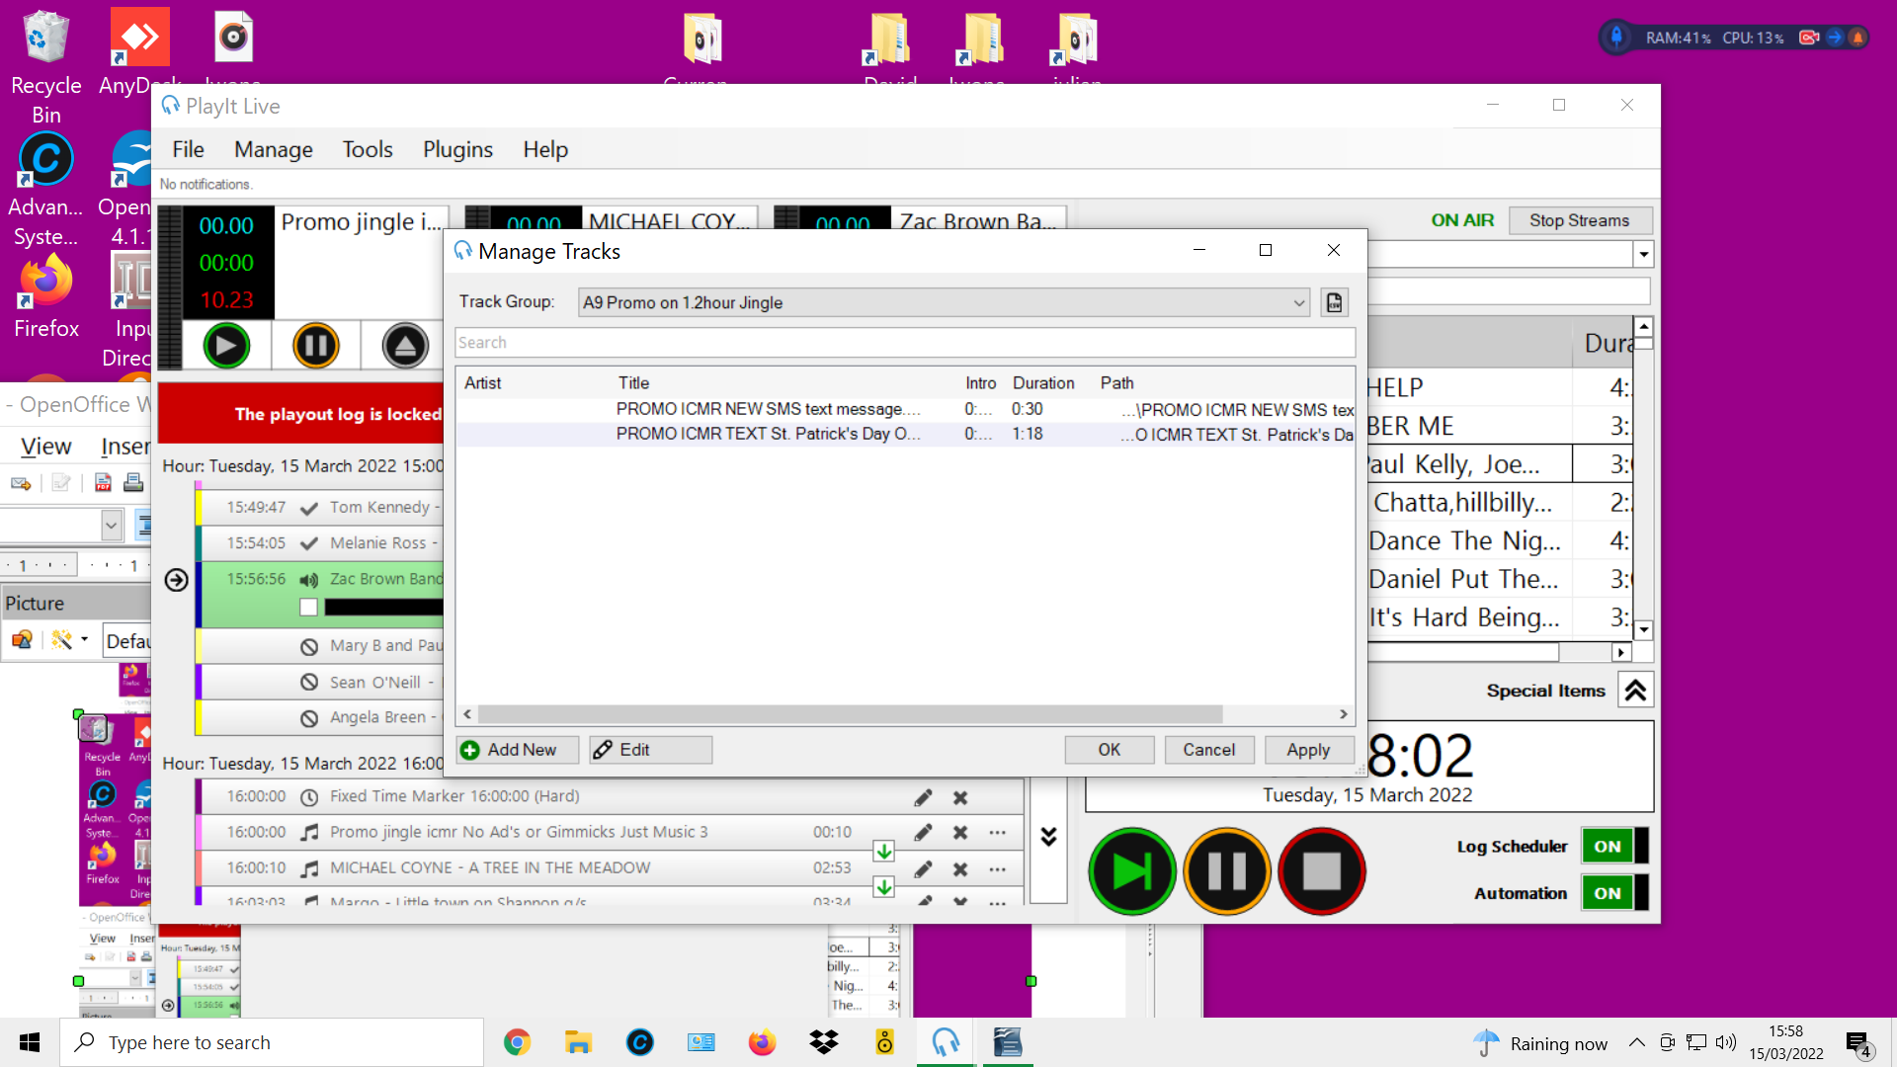
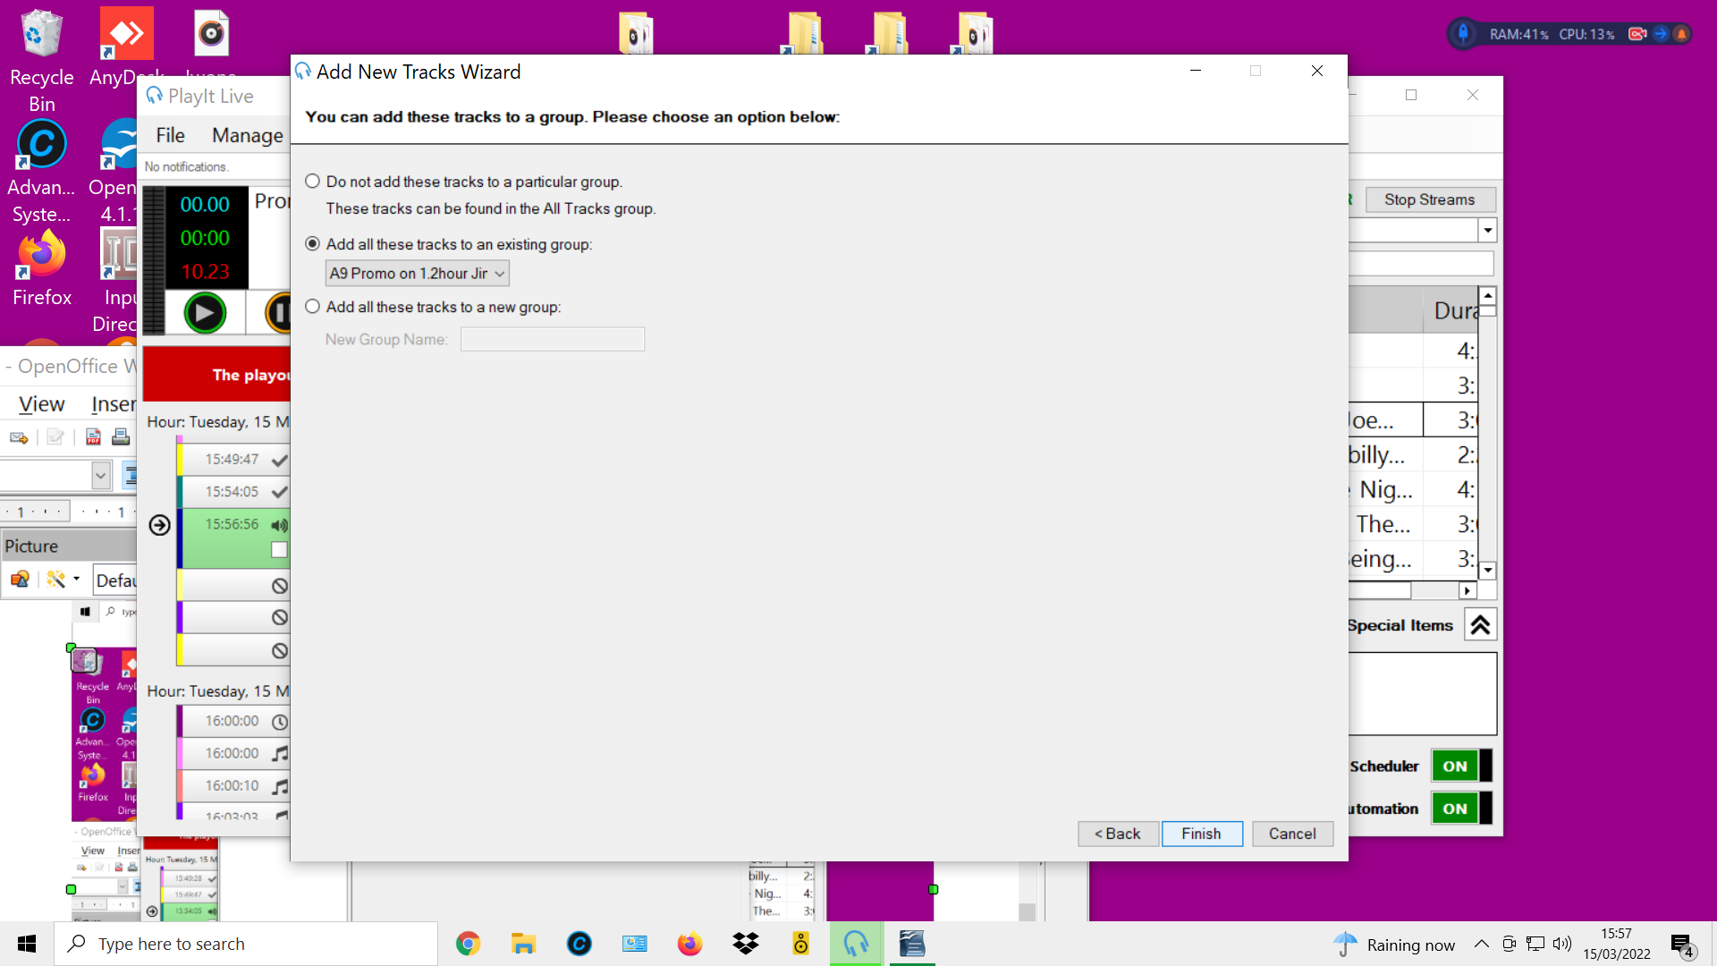
this is the page I wonder why you have to reselect the tracks to go to the existing group when you already selected the group at the start before click on add new

