Old jingles showing top of hr plus icmr limerick showing in folder
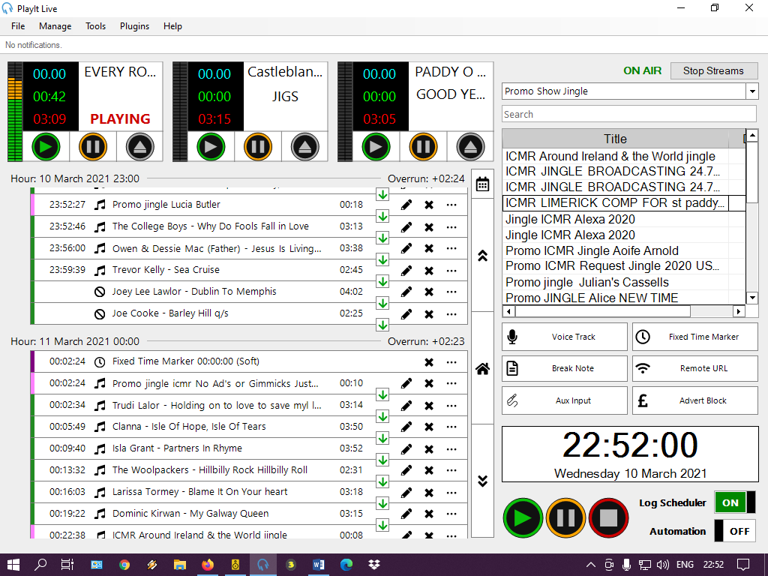
New jingle showing in clock as track
